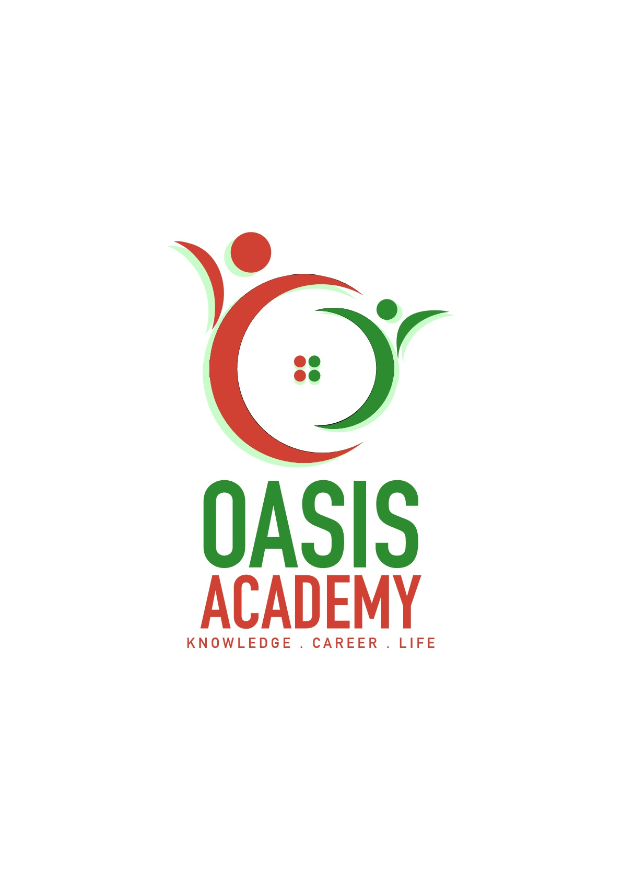

Name: Saravanan Subramaniam

Login ID: saravanan@oasis-portal.com

Course title: ESSENTIALS OF HUMAN RESOURSE

Subject Code: BHM 01

Submitted date: 05.06.2017

**Table of Contents**

|  |  |  |
| --- | --- | --- |
| **No** | **Details** | **Page** |
| 1 | Executive Summary | 2 |
| 2 | Introduction | 3 |
| 3 | Assignment Question |  |
|  | Part 1 | 4-6 |
|  | Part 2 | 7-9 |
|  | Part 3 | 10-11 |
|  | Part 4 | 12-14 |
| 4 | Conclusion | 15 |
| 5 | References | 16-18 |
|  | Appendix | 19-20 |

**Executive Summary**

The propose of this assignment is what I understand about human resource management. I will be defining the major activities of human resource management. In addition, I will be brief on human resource planning trend an in hotel industry. Thirdly I will talk about functions of human resource and policies. Finally I covered about organizational behavior in hospitality and explain structure in organization. . Its makes the importance of human resource management at hospitality the evident.

**Introduction**

Why do we need to study Human Resource Management? Human resource plays a strategic roles in managing people and the workplace culture and the environment. The function of human resource is recruiting, managing and directing people who work in it. Human resource are the most valuable and unique assets of an organization. These are several reason human resource is important to organization such as strategy, compensation, benefits, safety, liability, training and development, employee stratification, recruitment, selection and compliance. Human resource management also called personnel management consists of all the activities undertaken by an enterprise. Furthermore to ensure the effective utilization of individual, group and organization goals. In addition many popular media production have depicted human resource. One of the television series The Office human resource representative Toby Flenderson seen as a nag cause he will constantly remind to his coworker of company policies and government regulation.

**Assignment Questions**

**Question 1**

**Define the Major Activities and Human Resources Operation in Hospitality Management.**

**Answer**

What is human resource management? Human resource management has been commonly used for about last ten years. The field was generally known as personnel administration. The function performed in organization that the most effective use of people achieve organization and achieve goal. Is also a function management with hiring, motivating g and maintain people. The importance of human resource management is managing people, the work place culture and environment. It can be contribute to the overall company direction, goals and objectives.

Five major activities such as:

1. Recruiting

Became gatekeepers for when and how many to hire. Can ensure that the every position describe in detail so that new hires and veteran worker are clear about the duties and their responsibilities.

1. Training

New hires are must attend an orientation conducted by human resource. They are so given on job training. This is will help the new hires a peer perspectives and help them to develop relationship with other employee to work together as a team. Furthermore it will help to create training, training by trainer and implanting a tracking system to allow manager to monitor the course and related performance.

1. Selecting

Can be defined as a process of determining from among the applicants who can meet the job requirement and be offered the vacant position. In the selection process we cannot separate the person from his personal characteristic. In a contract of service between the employers and selected employee.

1. Motivation

Motivation can be understood as the desires or drive that an individual has to work and get the job done. To accomplish it that determine whether a particular individual would complete the task according. Its leads to underperformance and loss of competitiveness resulting in loss of product. Human resource manager stress on the employee having high levels of motivation to get the job done.

1. Evaluation

Evaluating the success of your business strategies involves assessing your employees’ ability to deliver outcomes. Integrating human resource management into your strategic planning process enables you to ensure that as you identify goals, opportunities and competitive advantages. That can recruit, hire and develop the right workforce to achieve the goals.

How does human resource work in hospitality management? Cause it will help to develop and improve in several part of hospitality management such as front office, housekeeping, food and beverages, security and maintenances. In a service industry such as the hotel, café and restaurants the human elements play major part in overall to make a success an organization.  The workforce (waiters, waitresses and receptionists) are in direct contact with the guests. Has been involved in an achieving the objective of the hotel or the restaurants. The quality of service offered is dependent. Not only upon the skills but also the attitudes and characteristic of the staff. Moreover the finishing product for which the customer is paying. Customer satisfaction is very important and likely to be affected as much by the standard of food and beverage, accommodation or other facilities of the hotel as by the courtesy, helpfulness and personal qualities of the staff. Therefore both the skills and the attitudes or characteristic of the workers are essential if the demands of the customer are to be meet satisfaction. This places particular importance on human resource management.

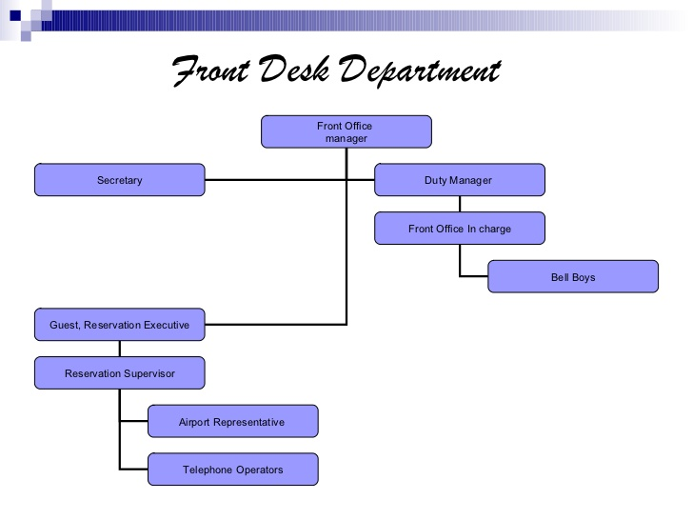

**Question 2**

**Describe in brief on Human Resources Planning and Planning Trend in Hospitality.**

**Explain about what is your understanding on Action Plan Human Resource Planning in Hotel Industry.**

**Answer**

Is to have an accurate number of employ­ees required, with matching skill requirements to accomplish organizational goals and achieve the targets. Human resource requirements of the organization and determining as to how the existing human resource capacity of the organization can be utilized to fulfill these requirements. Systematic human resource planning need five **R** such as

1. Right number
2. Right kind of people
3. Right time
4. Right place
5. Right job

Objective of human resource planning is forecast personnel requirement with different levels or skills, cope with changes, use existing manpower productively in the organization and last promote employees in the systematic way.

Human resource management planning trend in hospitality such as:

1. Outsourcing

Is creating talent pool to the new hires ad new candidate and by submitting information of the new applicants according the needs of organization? The final decision will made by corporation.

1. Internship

Is an opportunity offered by an employer to the potential candidate to work at a firm for fixed or limited time? Interns are usually student or undergraduate who work and study for six to twelve month. Practical give them more knowledge, gain experience and moreover team work with peer in the related industry of their field.

1. Poaching and raiding

The practice of forceful recruiting talented candidate or buying from the competitor rather than developing. Offering the employee an attractive package better the current staff. In high growth industries that rely on employee with skills.

1. E-recruitment

Is also known online recruitment, is the process with through of information technology and in particular using web-based resource for the task. Its involved receiving resume from e-mail. Moreover can advertise about the vacancy in website such as Facebook, Job Street, indeed and many more.

1. Talent pool

Create database using information technology to find candidate profile, interested in working in the organization. Also identify quality candidates for the future.

Action plan is a document what steps must be taken in order to achieve goals. Purpose is to clarify what resource are required to the reach the goal.

1. Assessing Human resource

It be easier for human resource to find out the strengths as well as weakness of the firm and opportunities... Moreover, it includes a records of the workers and skills already available within the firm and a comprehensive.

1. Demand Forecasting

The process of estimating demand for and supply of human resource in a firm and controlling the future needs for human resource in term of quality and quantity.  Human resource need can be guess with the help of the organization's current human resource situation and analysis of organizational plans an formula.

1. Supply Forecasting

It is concerned with the guess of supply of manpower given by the analysis of current resource and future availability of human resource in the company. It guess the future sources of human resource that are likely to be available from within an outside the organization.

1. Matching demand and supply

The matching process mention to bring demand and supply in an equilibrium position so that lack and over staffing position will be solved. In case lack of an organization has to appoint more required number of employees.

1. Action Plan

The major activities which are required to complete the human resource plan are [recruitment](http://accountlearning.blogspot.my/2013/01/human-resource-planning-process-or.html), [selection](http://accountlearning.blogspot.my/2013/01/human-resource-planning-process-or.html), placement, [training and development](http://accountlearning.blogspot.com/2013/03/concept-meaning-and-nature-of-human.html). This step is followed by control and evaluation of performance of human resource.  Which is worried

With surplus and shortages of human resource.

**Question 3**

**Brief about Human Resources Functions and Human Resources Policies.**

**Describe the Function of Management and how the policy applies accordingly in Hospitality Management.**

**Answer**

Human resource function.

The firm of the human resource department which are responsible for ensuring of employees. It is instrumental in providing labor law, recruitment, safety, compensation, and compliance and employee relation. These function are critical cause without those function being completed. The organization would not able to meet the essential need of the staff and management. Human resource

1. Recruitment

Hire primary responsible and skill of the human resource team, this part of the job often advertise open position, interviewing and hiring candidates. To attract the qualified applicant and to be encourage the unqualified applicants. Play key role by developing the workforce.

1. Safety

Workplace safety is very important factor. Employees have an obligation to provide a safe working environment to the workers. To support workplace safety training and maintain federally for workplace injury and fatality. Human resource also manage the company worker compensation issues.

1. Compensation and Benefits

One of the major function handle by human resource is the compensation and extra benefits. Compensation structure and evaluating competitive pay practicing. It may also covered festival bonus, joining bonus, and retirement. Health care also take care by the human resource management.

1. Employee relation

Another key function is the employee relation. When there is misunderstanding between employs it is the human resource who mediate the situation. It is also help to have good employee relation among the peer or in a team and building relationship with employees.

1. Compliance

Critical human resource function with that labor and the employment law. Based on unfair employment training, unsafe working environment and dissatisfaction with working condition. This can affect productivity and profitability. Must be aware state employment law and many other rules and regulations.

Human resource policies

Human resource policies are very important aspect of the workplace. They offer guideline on the approach a firm. In human resource department are created to help ensure equality, safety and consistency in the workplace. Human resource management policies such as organizational structure, legal issue, supervision guide and consistency.

Operation in the hospitality using human resource function.

The function of management applied in hotel industry. Helps business in the labor intensive in hotel industry set wages and salary. Based on regional market rates. Hospitality employees earn much more for their extra income through tips. Most critical problem are employment related. More people are interesting and exciting than entering the hotel industry, leaving hotel, restaurant, food and beverages, cafes and other hospitality. To attracting and retaining skill worked. A lack of employee’s satisfaction and training also be less in the industry.

**Question 4**

**Explain in detail about Organizational Behavior in Hospitality and brief on Groups and Structure in Organization.**

What is organization behavior? Is a social system and combined of humanity and technology. The study and application of knowledge about people act. Can be classified into four such as people, structure, technology and environment. In addition its effect on the firm functioning and performance. Organizational behavior both individual and group that occurs in firm.

Importance of organizational behavior is:

* Understand other behavior
* Maintain healthy working environment
* Understand the goals that need to achieve
* Relationship employee share with each other
* Making the company more effective

Organizational behavior in hotel industry. The following are the issued faced by the human resource in organizational behavior:

1. Workforce
2. Skills
3. Labor shortage
4. Declining loyalty

Behavior which is very important to improve relationships among the peers of people working together. Furthermore in the hotel industry the staff of various and different personality and character, join together in perform various job of the individual and group. To work towards improving organizational behavior. Hospitality management today is too competitive in economy and negative job attitudes are not good for the firm. Then job related attitude such as customer service significant role in hotel industry. To be hospitable with great attitude and skills with the guest. Moreover need to have team working skill and most important is the perception.

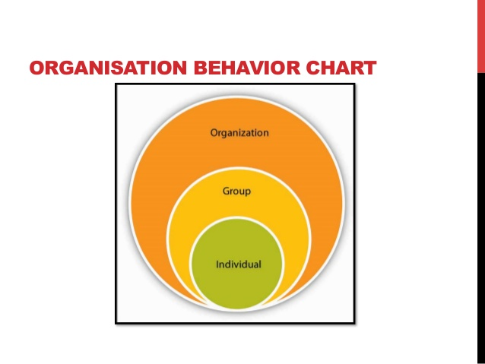

Organizational in groups.

Can be defined as two or more to interacting and be individually who come togather to achieve the goals or objective. Can be stated as a course of action groups takes a family. Classifying groups into task, command, interest and friendship. Here are five stage models for group development forming stage, storming stage, norming stage, performing stage and adjourning stage. Outcome is mean as group performance, quality work and able to work independently in the future. Group behavior is most important concept as they determine of the company culture and communication.

Organization structure.

Is a system used to define a hierarchy within an organization? Typical hierarchy is line authority, communication, right and duties of a firm. Then to identify each its function and where it to report within the firm. To develop establish how a firm operates and assist an organization in obtain its goal and allow to the future growth. The rules, power and responsibilities are assigned, controlled and coordinates. And also the information flow between the different levels of management. Having good organization will lead to better decision.

Six elements of the organization structure

1. Work specialization
2. Departmentalization
3. Chain of command
4. Span control
5. Centralization
6. formalization

**Conclusion**

* In this part, I finally learned and covered about human resource management and how it’s applied in hospitality management. Human resource management has come to be recognized as an inherit part of management, which is concerned with the human resource on an organization. Moreover maintenance of better human relation in the firm by developing and evaluating policies. Also concerned with getting better result with collaboration of people and their relationship within the enterprise. It is also help maintain individual development, working relationship among the peer and effective modeling of human resource as contracted with physical resource. These are several reason human resource is important to organization such as strategy, compensation, benefits, safety, liability, training and development, employee stratification, recruitment, selection and compliance. To have an accurate number of employ­ees required, with matching skill requirements to accomplish organizational goals and achieve the targets. Human resource requirements of the organization and determining as to how the existing human resource capacity of the organization can be utilized to fulfill these requirements. Action plan is a document what steps must be taken in order to achieve goals. Purpose is to clarify what resource are required to the reach the goal. Human resource function labor law, recruitment, safety, compensation, and compliance and employee relation. These function are critical cause without those function being completed. Human resource management policies such as organizational structure, legal issue, supervision guide and consistency. Importance of organizational behavior is Understand other behavior, Maintain healthy working environment and Relationship employee share with each other. Organizational group can be defined as two or more to interacting and be individually who come together to achieve the goals or objective. Organizational structure is typical hierarchy is line authority, communication, right and duties of a firm. Then to identify each its function and where it to report within the firm.

**References**

1. Zeinul Haleem (Sep 21, 2014) Human Resource Management in Hotel Industry

* <https://www.slideshare.net/ZeinulHaleem2/human-resource-management-in-hotel-industry>

2. Crystial Abram P. Parrilla (Jul 13, 2015) Introduction to Human Resource Management in Hospitality Industry

* <https://www.slideshare.net/CrystialParrilla/introduction-to-human-resource-management-in-hospitality-industry>

[3. Somitra Upadhyay](https://www.slideshare.net/SomitraUpadhyay?utm_campaign=profiletracking&utm_medium=sssite&utm_source=ssslideview) (Nov 27, 2014) HR Policies of Hotels

* <https://www.slideshare.net/SomitraUpadhyay/hr-policies-of-fortune-landmark-hotel-and>

# 4. Ruth Mayhew (1985) Key Human Resource Management Policies & Procedures

* <http://smallbusiness.chron.com/key-human-resource-management-policies-procedures-60802.html>

5. [Dr. Rajasshrie Pillai](https://www.slideshare.net/rajasshrie1?utm_campaign=profiletracking&utm_medium=sssite&utm_source=ssslideview) (Aug 22, 2014) Chapter 1 Organizational Behavior

* <https://www.slideshare.net/rajasshrie1/chapter-1-ob-38248150>

6. Dr. Daisy Chauhan (May 8, 2009) Basic Concepts of Organizational Behavior

* <https://www.slideshare.net/manishray/1basicconceptsofob>

7. UK essays (23rd March, 2015) Importance of Human resource management in Hospitality Industry Tourism Essay

* <https://www.ukessays.com/essays/tourism/importance-of-hrm-in-hospitality-industry-tourism-essay.php>

8.  Aditya Modani (Dec 3, 2007) Human Resource Planning In Hotel Business

* <https://www.slideshare.net/guest61a8d3/human-resource-planning-in-hotel-business?qid=f3337641-290d-4276-85f7-ba2a50f1eee5&v=&b=&from_search>=

9. Giovanni Macahig (Jun 29, 2013) Fundamentals of organizational behavior ppt

* <https://www.slideshare.net/rahu1515/fundamentals-of-organizational-behavior-ppt>

10. Payal Deep (Dec 17, 2012) Organizational behavior

* <https://www.slideshare.net/payalrchhabra/organisational-behavior-15668552>

# 11. Ruth Mayhew (1985) 10 Reasons HR Is Important to an Organization

* <http://smallbusiness.chron.com/10-reasons-hr-important-organization-22424.html>

12. Wikipedia

* <https://en.m.wikipedia.org/wiki/Human_resource_management>

13. George Elton mayo

* <http://www.whatishumanresource.com/the-historical-background-of-human-resource-management>

# 14. 17 June, 2011 [the Importance of Human Resource Management](https://www.griffith.ie/blog/importance-human-resource-management)

* <https://www.griffith.ie/blog/importance-human-resource-management>

# 15.  Ruth Mayhew (1985) What Are the Functions of Human Resource

* <http://smallbusiness.chron.com/functions-human-resource-managers-1326.html>

# 16.  Lisa Mooney [Key Functions of an HR Department](http://smallbusiness.chron.com/key-functions-hr-department-31206.html)

# <http://smallbusiness.chron.com/key-functions-hr-department-31206.html>

# 17.  Ruth Mayhew (1985) [Six Main Functions of a Human Resource Department](http://smallbusiness.chron.com/six-main-functions-human-resource-department-60693.html)

* <http://smallbusiness.chron.com/six-main-functions-human-resource-department-60693.html>

18. Wikipedia

* <https://en.m.wikipedia.org/wiki/Human_resource_policies>

# 19.  Valerie Bolden-Barrett the Role of the Human Resources Department in a Hospitality Organization

* <http://smallbusiness.chron.com/role-human-resources-department-hospitality-organization-71891.html>

20. Keerthi Rohit (Apr 23, 2009) Group Behavior

* <https://www.slideshare.net/mobile/kirthi.t/group-behavior>

**Appendix**



Figure 1. Human resource planning in Hotel business adapted from Aditya Modani.(2007 slide 10).



Figure 2. Organization behavior adapted from Payal Deep (2012 slide7).

THE END